Mini Project
Class & Batch |  | : | TE7 K7 |  | Group No. |  | : | K7-7
Synopsis
on
“DEXTROUS - 6 DOF Robotic Arm”

Submitted By
Roll No. | Name of the Student |  |  | e-mail id |  | Mobile No.
32112 | Vishal Bhokre |  |  | vishalbhokre99@gmail.com |  | 9922045868
32113 | Vedant Butala |  |  | vedantbutala@gmail.com |  | 7218633303
32132 | Sumedh Kasat |  |  | sumedhkasat32@gmail.com |  | 8698756932
Project Guide
Prof. Lalit Patil
DEPARTMENT OF ELECTRONICS AND TELECOMMUNICATION ENGINEERING
PUNE INSTITUTE OF COMPUTER TECHNOLOGY

Academic Year : 2023 – 2024

- Project Title: Dexterous – 6 DOF Robotic arm

- Introduction/ Motivation:
Our project germinated from a shared enthusiasm for robotics, catalyzed by a team member's proposal to engineer a 6-DOF robotic arm. Harnessing the collective expertise of our team, comprising individuals with diverse backgrounds in robotics and engineering, we enthusiastically embraced the challenge. Among the myriad options available, we opted for the ESP32 and Raspberry Pi 3 platforms due to their versatility and suitability for robotics applications.
Motivated by the dual objectives of innovation and skill enhancement, we recognized the project as an opportunity to contribute meaningfully to the realm of automation technology. Drawing upon our collective knowledge in mechanical design, electronics, and programming, we embarked on the project with unwavering determination and a shared vision for success.
Despite anticipating inevitable hurdles along the journey, we approach them with a spirit of resilience and resourcefulness. Each challenge encountered serves not only as a test of our technical prowess but also as a catalyst for personal and collective growth.
At its core, our project's background epitomizes a convergence of passion, expertise, and ambition. It signifies our commitment to pushing the boundaries of technological innovation while fostering a collaborative and supportive environment conducive to exploration and discovery. Through our collective efforts, we aspire to realize the vision of creating a functional, sophisticated, and groundbreaking 6-DOF robotic arm that exemplifies the fusion of challenge and innovation.

- Literature Survey / Prior work:
Literature Survey: Advancements in 6-DOF Robotic Arms with Locomotion

Introduction:
In recent years, there has been a growing interest in developing versatile robotic arms capable of both agility and mobility. This literature survey explores key studies focusing on 6-DOF robotic arms utilizing ESP32 and Raspberry Pi 3 controllers, highlighting advancements in control capabilities, affordability, and integration with locomotion.
Study 1: "Advanced Robotic Arm Control via IoT with ESP32 and Raspberry Pi 3" (2020)
- Features: 6 DOFs, ESP32, Raspberry Pi 3, IoT connectivity.
- Insight: This study demonstrates advanced control capabilities facilitated by IoT connectivity, showcasing the potential of ESP32 and Raspberry Pi 3 in orchestrating complex robotic arm movements.
- Source: Academia.edu

Study 2: "Affordable 3D-Printed 6-DOF Robotic Arm with ESP32 and Raspberry Pi 3" (2021)
- Features: 6 DOFs, 3D-printed, Bluetooth control.
- Insight: Highlighting affordability and flexibility, this study emphasizes the role of 3D printing in creating cost-effective 6-DOF robotic arms. The integration of Bluetooth control further enhances accessibility.
- Source: Hiwonder
Study 3: "Integrating Locomotion with a 6-DOF Robotic Arm using ESP32 and Raspberry Pi 3" (2019)
- Features: 6 DOFs, mounted on mobile platform, synchronized control with Raspberry Pi 3.
- Insight: This study successfully integrates arm manipulation with mobile locomotion, showcasing the synergy between ESP32, Raspberry Pi 3, and the mobility platform. Such integration opens up new possibilities for robotic applications.

- Problem Definition and Objectives:
1. Achieve Precise Control:
Develop control algorithms and mechanisms to ensure smooth and accurate movement of the robotic arm utilizing ESP32 microcontroller and servo motors, enabling precise positioning and manipulation of objects.

2. Enable Object Manipulation:
Design the robotic arm to effectively grasp and manipulate objects of diverse shapes and sizes, implementing grippers and manipulators with adjustable grip strength and adaptability.

3. Implement Wireless Communication:
Utilize the ESP32 microcontroller to enable wireless control of the robotic arm via Wi-Fi or Bluetooth, supporting multiple user interfaces such as joystick control, web applications, or smartphone apps for seamless operation.

4. Design User-Friendly Interface:
Create an intuitive and user-friendly control interface accessible to users of all skill levels, incorporating ergonomic design principles and intuitive controls for ease of operation and navigation.

5. Optimize Power Efficiency:
Employ power management techniques to optimize battery life or power supply, ensuring extended operation of the robotic arm while minimizing energy consumption and maximizing efficiency.

6. Integrate Locomotion Capabilities:
Implement effective movement capabilities for the robotic arm, enabling integration with locomotion systems to navigate and maneuver in various environments, enhancing its mobility and adaptability.

7. Allow End-Effector Customization:
Enable customization of end-effectors to suit specific tasks and applications, providing versatility and flexibility in performing a wide range of functions and operations.

8. Ensure Safety Measures:
Integrate safety features such as obstacle detection sensors, emergency stop mechanisms, and secure operation protocols to ensure safe and reliable operation of the robotic arm, mitigating risks and hazards in its environment.

- Circuit Diagram:
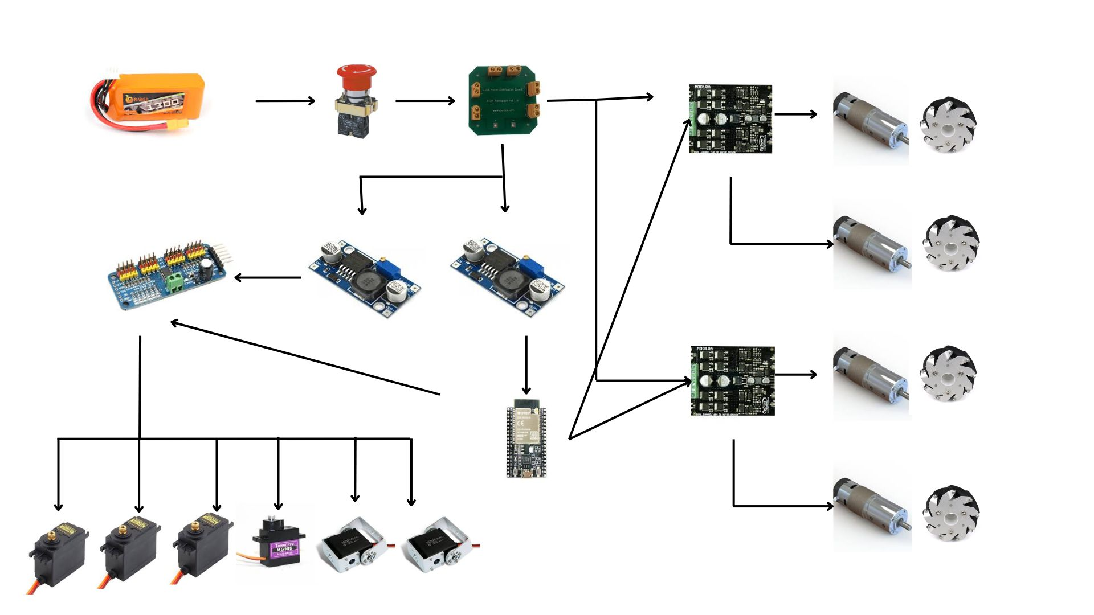

CAD Diagram:
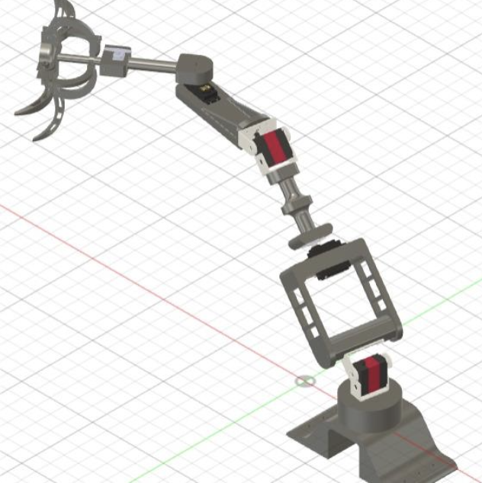

- Hardware Requirements:
1) Kill Switch
2) Battery 12V LiPo Battery 3 Cells
3) PCA 9685 module Servo Driver
4) ESP32 microcontroller
5) Jumper Cables (Male to Female and Female to Female)
6) Wires
7) PDB Board for Power Distribution
8) LEDs and Resistors and switches
9) Cytron Motor Drivers MDD10A
10) IG 42 motors x4
11) MG995 Servos ×3
12) DS3115 Servo ×2
13) SG90 Servo x1
14) Buck Converters x2

- Software Requirements:
- KiCAD
- Arduino IDE 2.2.1
- Fusion 360

- References:
Mohd Ashiq Kamaril Yusoff's, Reza Ezuan Samin, Babul Salam Ksm Kader Ibrahim, “Wireless Mobile Robotic Arm”, ELSEVIER, ResearchGate, December 2012, 1072-1078.
https://iotdesignpro.com/articles/iot-based-robotic-arm-controlling-using-esp32
https://www.academia.edu/50180450/Design_and_implement_of_robotic_arm_and_control_of_moving_via_IoT_with_Arduino_ESP32
https://ozrobotics.com/shop/hiwonder-maxarm-robot-arm-powered-by-esp32-support-python-and-arduino-programming-standard-kit/
https://www.researchgate.net/publication/333886109_A_Cost-Efficient_Multipurpose_Service_Robot_using_Raspberry_Pi_and_6_DOF_Robotic_Arm
https://grabcad.com/library/robot-arm-83
https://docs.google.com/spreadsheets/d/1wXcu2AezT9oymwPx0rUag4GGjRIw_IFt9GSfBZX83_Y/edit#gid=0

